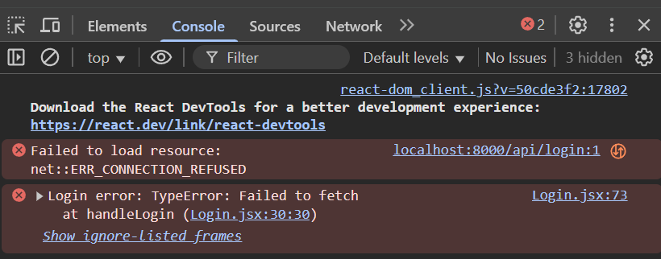
HOW TO FIX THIS BUG:
1. Navigate to caps-frontend
2. Update .env file in caps-frontend from:
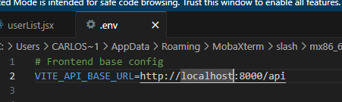
To:
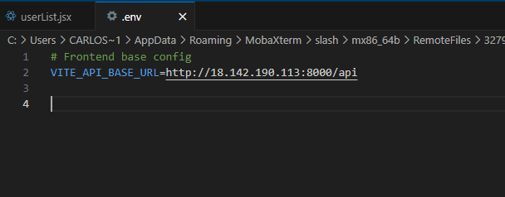

3. Press CTRL + S , to save
4. Navigate to caps-frontend/src/components/userlist.jsx
5. Update userlist.jsx from :
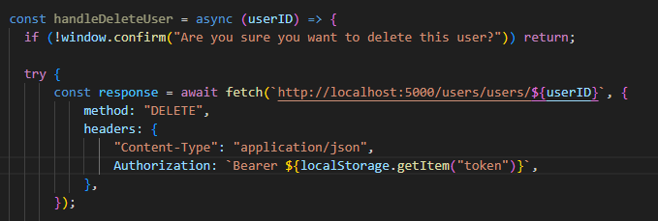
And:
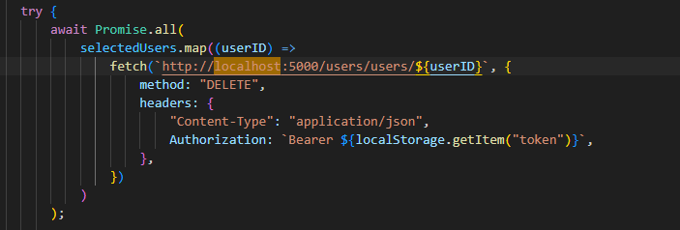
To:
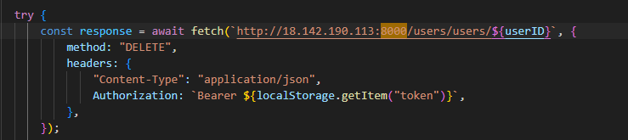
And:
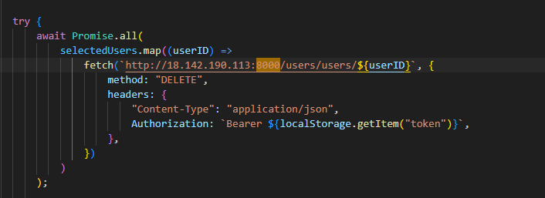
6. Press CTRL + S
7. The website should be working

